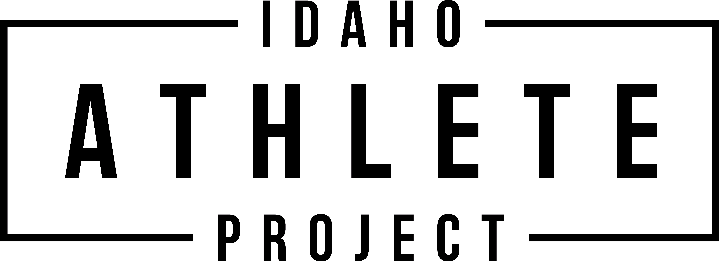

Participant Waiver, Release of Liability, and Indemnification Agreement
I, the undersigned participant, acknowledge, agree, and understand that:

- Voluntarily and of my own free will, I elect to participate in activities conducted by the Idaho Athlete Project, LLC (“Idaho Athlete Project”) or within its facilities. Furthermore, I agree that I am in good health and proper physical condition to participate in said activities.
- I understand that there are inherent risks and hazards involved in participating in all activities with the Idaho Athlete Project or within its facilities that may result in injury or death to me or other participant including, but not limited to those hazards associated with, playing conditions, equipment, and other participants.
- I understand that these activities can be dangerous to me and to other participants and may result in serious injury or death.
- I understand that the very nature of my participation in activities at or in conjunction with the Idaho Athlete Project is hazardous and risky, including, but not limited to, the acts of using equipment, training, running, jumping, stretching, sliding, lifting, engaging in sport specific activities and collisions with other participants and with stationary objects, all of which can cause serious injury or death to me and to other participants.
Further, I, the undersigned participant, agree that in consideration for the right to participate and engage in activity with the Idaho Athlete Project or at its facilities and in consideration for permission to participate:
- I voluntarily elect to accept and assume all risks of injury incurred or suffered by me (a) while engaged in any activity conducted by the Idaho Athlete Project, its employees, trainers, managers, representative or agents, and (b) while on or upon the premises of any Idaho Athlete Project property or facility.
- I hereby release, discharge and agree not to sue the Idaho Athlete Project, or their owners, officers, agents, servants, associations, employees, or any person or entity connected with the Idaho Athlete Project for any claim, damages, costs or cause of action which I have or may in the future have as a result of injuries or damages sustained or incurred by me from whatever cause including but not limited to the negligence, breach of contract or wrongful conduct of the parties hereby released.

I ACKNOWLEDGE THAT I HAVE READ AND THAT I UNDERSTAND EACH AND EVERY ONE OF THE PROVISIONS IN THIS WAIVER, RELEASE OF LIABILITY AND INDEMNIFICATION AGREEMENT AND AGREE TO ABIDE BY THEM.

Name of Participant (Print) Phone

Signature of Participant (if 18 years old) Date

Parent/Guardian Waiver, Release of Liability and Indemnification Agreement
I, the undersigned parent or guardian of the above-named minor, acknowledge, agree and understand that:
- The above-named minor is in good health and proper physical condition to participate in all activities with and at the Idaho Athlete Project facilities.
- There are certain risks and hazards involved in the above-named minor participating in activities with and at the Idaho Athlete Project facilities that may result in injury or death to the minor or other participants including, but not limited to those hazards associated with, facility conditions, equipment, and other participants.
- I hereby release, discharge and agree not to sue the Idaho Athlete Project or their owners, officers, agents, servants, associations, employees, or any person or entity connected with the Idaho Athlete Project for any claim, damages, costs or cause of action which I have or may in the future have as a result of injuries or damages sustained or incurred by the above named minor from whatever cause including but not limited to the negligence, breach of contract or wrongful conduct of the parties hereby released.

I ACKNOWLEDGE THAT I HAVE READ AND THAT I UNDERSTAND EACH AND EVERY ONE OF THE PROVISIONS IN THIS WAIVER, RELEASE OF LIABILITY AND INDEMNIFICATION AGREEMENT AND THAT I HAVE LEGAL AUTHORITY TO WAIVE ANY AND ALL CLAIMS ON BEHALF OF THE ABOVE NAMED MINOR PARTICIPANT.

Name of Parent or Guardian Phone

Signature of Parent or Guardian Date

